Table of Contents
Introduction 3
Task 1: Data Warehouse Design Document 4
Key Concepts of Databases and Data Warehousing 4
Application of Database Concepts to the SMP Retail Scenario 5
Entity Relationship Diagram Design 6
Benefits of Implementing a Data Warehouse for SMP Retail 8
Task 2: Implementation 10
Building the Data Warehouse Using a Snowflake Schema 10
Fact Table and Dimension Tables 11
Power BI Implementation of the Warehouse Model 13
Task 3: Emerging Trends and Ethical Concerns 16
Integrating the Data Warehouse with BI Tools and Data Analytics 16
Cleaning, Transforming and Loading Data Using MS Power BI 16
Data Visualisation and Enhanced Decision-Making 19
Ethical Concerns: Privacy, Security and Bias 20
Conclusion 22
References 23
Appendices 25
Appendix A: Power Query Cleaning and Transformation Evidence 25
Appendix B: Power BI Data Model 27
Appendix C: DAX Measures Used 28

List of figures:
Figure 1: Conceptual ERD Showing Sales, Invoice, Date and Time Relationships 7
Figure 2: Entity Relationship Diagram for the SMP Retail Data Warehouse 8
Figure 3: Snowflake Schema for the SMP Retail Data Warehouse 11
Figure 4: Power BI Data Model Showing Fact and Dimension Relationships 15
Figure 5: Power Query Cleaning and Transformation Steps 18
Figure 6: SMP Retail Sales Performance Dashboard 20
Figure 7: Product Sales Detail Analysis Dashboard 21

List of tables:
Table 1: Application of Database and Warehouse Concepts to SMP Retail 6
Table 2: Proposed Fact and Dimension Tables for SMP Retail 9
Table 3: Power BI Measures Used in the Sales Dashboard 12
Table 4: Main Power Query ETL Steps Applied to the Retail Dataset 15
Table 5: Ethical Risks and Mitigation Strategies for SMP Retail 18

Introduction
SMP Retail is a large regional retail organization, producing several types of data every day, such as point of sale details, the types of products customers are buying, and how the shops operate. Currently, each store manager relies on local store POS reports for decision making related to inventory, staffing, promotions, and the performance of the store. This results in a fractured decision making process, because the stores can react to a line of demand/customer behaviour in different ways. This can lead to stock-outs, overstocks, inaccurate reporting and lost opportunities for optimizing sales.
It is proposed in this report to create a data warehouse solution for SMP Retail. The goal is to consolidate sales, customer, product and store data in one central analytical model, which could be used for business intelligence and improved management decision making. The report begins by introducing important database and data warehouse terminology and relating it to the retail business. It subsequently provides an ER Diagram and a Snowflake Model of the designed Warehouse. Of equal significance, it describes the steps taken for cleaning an experimental retail data set and how it was transformed and visualised in Microsoft Power BI.
The demonstration is given with an extract derived from the Online Retail II data. The original data source is from a UK online retail store with transactions made between 01/12/2009 and 09/12/2011, including a variety of fields, such as invoice, product, quantity, price, customer and country (UCI Machine Learning Repository, 2019). While incomplete SMP Retail data set with every physical store attribute necessary for a full SMP Retail implementation, it is a realistic transactional data set for demonstrating data warehousing, ETL and BI reporting.

Task 1: Data Warehouse Design Document

Key Concepts of Databases and Data Warehousing
A database is an organized collection of data that allows the storage, retrieval and management of data. Databases are popular in an operational retail system like a point of sale (POS) system, or a customer loyalty system, or stock and product catalogues. These are the systems that are used in everyday transactions. When customers purchases a product, for instance, the database of the point of sale stores the invoice number, the product code, the quantity purchased, the price and the date and customer identifier.
The purpose of a data warehouse is different. It is unfamiliar with support individual transactions but is instead used for reporting, historical analysis and decision support. A warehouse, says Inmon (2005), is a data store that is integrated, time variant, and is used for management decision making. Kimball and Ross (2013) also focuses on dimensional modelling, which is a method that shows business processes and states them in terms of measurable facts and descriptive dimensions. SMP Retail can relate to this as the sales activity can be measured in quantity, price, sales amount, and product, customer, date and country can give context.
Another explanation is happening through OLTP vs. OLAP. OLTP systems are designed to handle operational transactions, for example, recording a sale rapidly and accurately. OLAP systems can be used for analysis, e.g. sales by month (or quarter) by product by customer by country. While local databases of POS data can answer the question “what did this store sell today?” for SMP Retail, a data warehouse can answer broader questions like “which products generate the most revenue?” or “which customers and regions are most valuable?”. Microsoft (2024) states that fact tables contain business events and numeric measures, and dimension tables contain descriptive attributes that can be used to filter and group the facts.

Application of Database Concepts to the SMP Retail Scenario
This common retail challenge is illustrated in the SMP Retail case – data is available, but asymmetrical way. Each store produces their own store level POS data and decisions are still made independently. This can cause varying stores to have varying assumptions regarding their stock and staffing/promotions. One branch can oversell slow moving inventory, and another branch may be out of products that are popular at similar branches.
A data warehouse would enable SMP Retail to have a single analytical environment that includes a combination of all these elements, including their POS transactions, customer data, product data and store-specific criteria. POS data would give you data on the sales activity like invoice number, product code, quantity, price, date etc. Customer data would be used in purchase behaviour analysis and loyalty analysis. Product data would be utilized for category and supplier analysis. Data to be stored would include facility size, layout, staffing and location for purposes of making comparisons.
For the Power BI demonstration, the data set provided enabled a simplified version of this warehouse. A cleaned FactSales_Clean table was joined to dimensions of product, customer, date and country. This enabled to display the total sale, total quantity, total invoice, number of customers, product ranking, sales trends, geographic sales pattern on a monthly basis in the dashboard. In a complete SMP Retail system, dimensions could be added for store, region, supplier and promotion to the above.
Figure 1: Conceptual ERD Showing Sales, Invoice, Date and Time Relationships

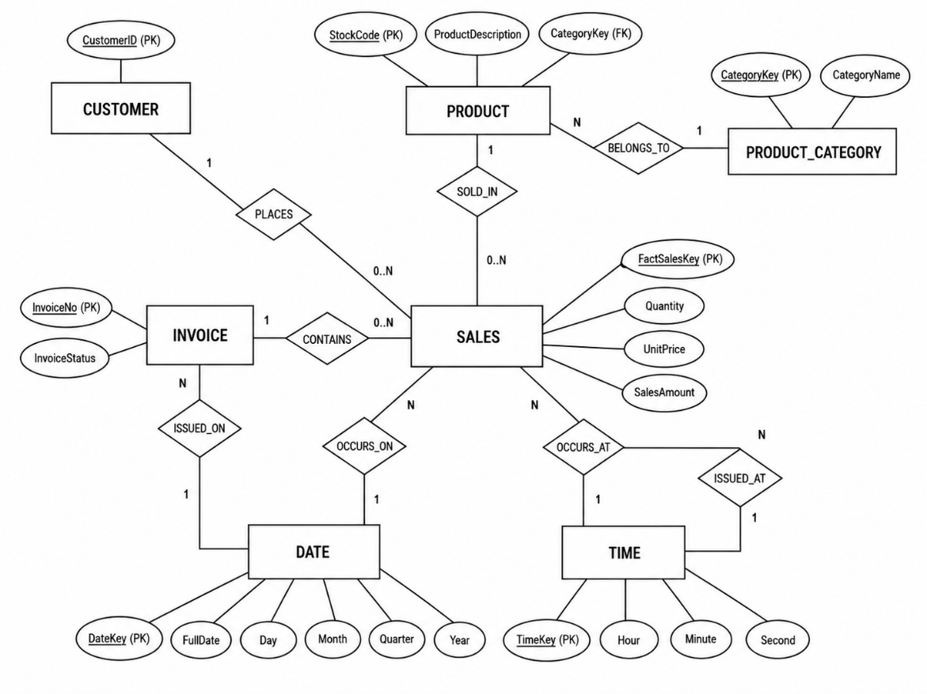
The ERD model for the sales Data Warehouse of SMP Retail is shown in Figure 1. The Sales entity has been maintained as the center as it holds the measurable details of the transaction like quantity, unit price and sale amount. Customer is directly related to Sales with the PLACES relationship, and Invoice is related to Sales with CONTAINS and to Date and Time with ISSUED_ON and ISSUED_AT relationships. This simplifies the model, as the data on customer activity, invoice details, product category information, and date-time is now neatly encapsulated and is related to the sales process.

Entity Relationship Diagram Design
The ERD shows the main entities required for the proposed retail data warehouse. The sales entity is at the centre, because there is the primary business event, which is the customer ordering a product at a specific time and date from an invoice, or sales entity. In order to understand that sale, one must look at related entities that provide context to that sale. These include Product stores product-level information, Product Category supports grouping, Customer identifies the purchaser, and Date and Time supports trend analysis.
Figure 2: Entity Relationship Diagram for the SMP Retail Data Warehouse
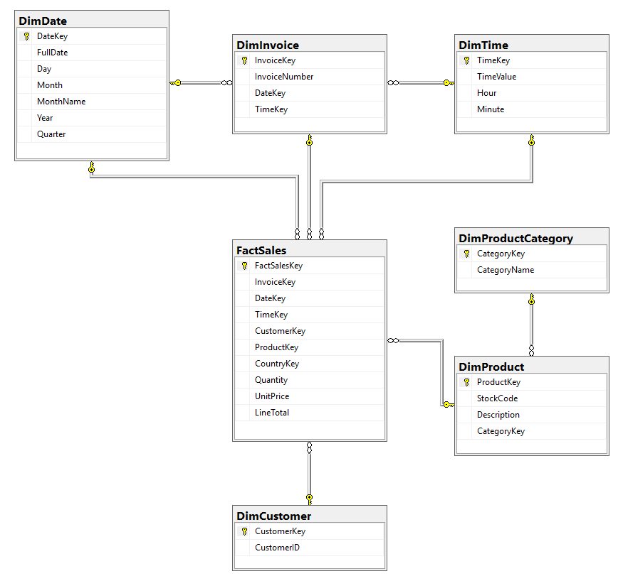
This structure is helpful in that it separates out measurable sales activity from descriptive information. The sales values like quantity, price and line total should be stored in the sales area and the product names, customer identifiers and date attributes should be stored in another area. This helps to liminate redundancy unnecessary information and makes reporting easier. Another benefit of the ERD is that it represents a bridge from the business problem to what will be discussed later as the warehouse schema, as it illustrates what data needs to be related prior to the useful reporting work being done.
The diagram also illustrates a drawback to the experimental data set. This data will contain details of customer, product, date/country but will exclude full store level details like store size, layout or staffing. These would need to be added in a full SMP Retail implementation.

Benefits of Implementing a Data Warehouse for SMP Retail
The first comes in the form of better decision-making. A centralized warehouse would provide SMP Retail with a unified view of sales, customers, products and geographical locations as opposed to numerous store-level reports. This enables managers to look across business and cuts down on reliance of individual spreadsheets.
The second advantage is that it is an improvement in product and inventory analysis. SMP Retail can identify high value products as well as fast moving items by analysing the above by revenue and quantity sold. This is important due to the fact that a product that has a large volume of sales modest financial returns bring in the highest revenue. This can be backed up by the Power BI dashboard by displaying the Top 10 Products by Sales Revenue and Top 10 Products by Quantity Sold.
The third advantage is a better customer understanding. Customer dimensions enable SMP Retail to recognize valuable customers and insights into buying trends. Customer insight, inventory optimisation and decision-making, as well as sales analysis, are also recent areas of research for retail analytics that validate the application of Power BI in the retail sector (Quoc, 2025).
But there are also challenges when it comes to implementation. This first is the issue of data quality. Missing data, duplicate rows, cancelled invoices and returned items are examples of retail data that can include such items. These unprocessed records can make the dashboard totals misleading. There is integration as various stores will vary their own POS system, product codes or product naming. There are other factors to consider such as cost running and training of staff and maintenance. Equally important, privacy and security should be considered as customer information on their purchasing habits may show behaviour patterns. ICO (2023) outlines principles to guide the way data is handled in the form of accountability, security, storage limitation, accuracy and data minimisation.
Table 1: Application of Database and Warehouse Concepts to SMP Retail
Concept | Meaning | Application to SMP Retail
Operational database | Stores daily transaction records | POS systems record sales, products, prices and invoices
Data warehouse | Central analytical data store | Combines POS, customer, product and store data for reporting
Fact table | Stores measurable business events | Sales quantity, unit price and total sales amount
Dimension table | Stores descriptive context | Product, customer, date, invoice and country details
ETL process | Extracts, cleans and loads data | Removes duplicates, returns and invalid records before analysis
BI dashboard | Visualises business performance | Shows KPIs, product rankings, sales trends and geography

Task 2: Implementation

Building the Data Warehouse Using a Snowflake Schema
The proposed warehouse will have a snowflake schema. A snowflake schema is a dimensional schema that has a fact table in which a fact is followed by a number of associated dimension tables that give the fact its context in descriptive terms. Several dimensions are also possible to be normalised into sub-dimensions. This would be appropriate in the case of SMP Retail as they have a need to check sales based on product details, customers, invoice number, date and location details etc.
Figure 3: Snowflake Schema for the SMP Retail Data Warehouse
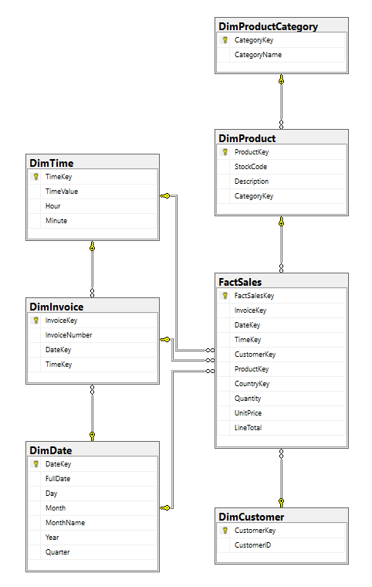
In the suggested schema, FactSales is the hub of the ware house. One can say so, as sales are the primary business process to be analysed. SalesTransactionAnalysis. FactSalestransaction contains one row for each sales transaction line, and includes measures like Quantity, UnitPrice and LineTotal. It also has keys associated that make the connection of each sale to other associated dimensions.
An understanding of the surrounding dimensions provides an understanding of the sale. DimCustomer contains information about customers; DimProduct contains information about products; DimProductCategory is a category that clusters products together; DimInvoice contains information about the reference of an invoice; DimDate and DimTime allow for historical and time-based analysis. Geographic reporting is included as part of the Power BI demonstration by DimCountry. If envisioned as a full-fledged SMP Retail application, dimensions of store and region might be included as well.
This is a dimensional modelling construction as it avoids mixing up measures and context. In dimensional models, Kimball and Ross (2013) say that models should match business processes and at the same time be comprehensible to business users. Additionally, Microsoft (2024) advocates for the use of fact and dimension modelling in Power BI as it enables intuitive measures to be more clearly and effectively filtered and grouped.

Fact Table and Dimension Tables
The schema's focus table is FactSales. This table contains measurable values of sales like quantity, unit price, line total. It also contains foreign keys to connect the sales record to the appropriate descriptive dimensions. The relevance of the separation for a data warehouse is that only facts should be stored in the fact table while dimensions should be populated with any descriptive information that would be valuable for business reports.
Table 2: Proposed Fact and Dimension Tables for SMP Retail
Table | Type | Purpose | Relevant attributes
FactSales | Fact | Stores sales measures | FactSalesKey, InvoiceKey, ProductKey, CustomerKey, Quantity, UnitPrice, LineTotal
DimCustomer | Dimension | Describes customers | CustomerKey, CustomerID
DimProduct | Dimension | Describes products | ProductKey, StockCode, ProductDescription, CategoryKey
DimProductCategory | Dimension | Groups products | CategoryKey, CategoryName
DimInvoice | Dimension | Stores invoice information | InvoiceKey, InvoiceNo, DateKey, TimeKey
DimDate | Dimension | Supports calendar analysis | DateKey, FullDate, Month, Quarter, Year
DimTime | Dimension | Supports time-of-day analysis | TimeKey, TimeValue, Hour, Minute
DimCountry | Dimension | Supports geographic analysis | CountryKey, CountryName
DimStore | Dimension | Describes store-level operations | StoreKey, StoreID, StoreLocation, StoreSize, StoreLayout, StaffingLevel

DimStore would be added in a full SMP Retail implementation to support analysis of store operations, staffing, location, store size/layout. As geography information is available only in Country, it was used as the available geography dimension in the Power BI prototype.The measures are stored in a fact table, and the descriptive information used for analysis is stored in dimension tables. It is critical to this separation because retail managers tend to ask business questions contextually – sales by month, product, customer or country – and so on. This is achieved by using a dimensional model, which enables one set of sales measures to be sliced and diced by varying dimensions.
The data that was used in the experiment contained InvoiceNo, ProductCode, ProductDescription, Quantity, InvoiceDateTime, UnitPrice, CustomerID and Country. These fields were created by Power BI transformations from these fields: SalesAmount and SalesDate. Zero physical store attributes were available in the dataset, so the only available geographic dimension was, Country.

Power BI Implementation of the Warehouse Model
A simplified version of the warehouse was implemented in the Power BI model. FactSales_Clean was related to DimProduct (ProductCode), DimCustomer (CustomerID), DimDate (SalesDate), and DimCountry (Country). These relationships enables dimension tables to filter a central fact table. Typically, dimension table is the “one” side of one-to-many relationships, and the fact table is the “many” side (Microsoft, 2025).
Figure 4: Power BI Data Model Showing Fact and Dimension Relationships
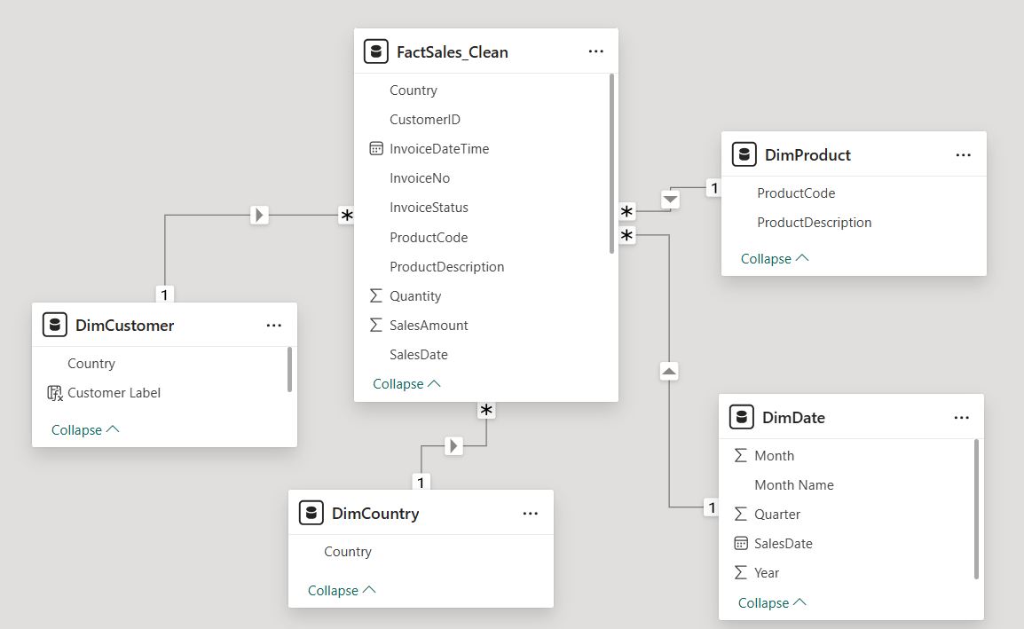
The following 5 DAX measures were developed: Total Sales, Total Quantity, Total Invoices, Total Customers and Average Basket Value. This enabled the same calculations to be applied across all KPI cards, trend charts and product/customer visualisation.
Table 3: Power BI Measures Used in the Sales Dashboard
Measure | Purpose | DAX calculation
Total Sales | Calculates total revenue | SUM(FactSales_Clean[SalesAmount])
Total Quantity | Calculates total items sold | SUM(FactSales_Clean[Quantity])
Total Invoices | Counts unique invoices | DISTINCTCOUNT(FactSales_Clean[InvoiceNo])
Total Customers | Counts unique customers | DISTINCTCOUNT(FactSales_Clean[CustomerID])
Average Basket Value | Calculates average revenue per invoice | DIVIDE([Total Sales], [Total Invoices])

This is incomplete enterprise warehouse, but a working prototype. It demonstrates the retail transaction data and how it can be cleaned, modelled using fact and dimension tables, and utilized for interactive reporting.

Task 3: Emerging Trends and Ethical Concerns

Integrating the Data Warehouse with BI Tools and Data Analytics
BI tools are an advantage and add value to a data warehouse. The warehouse gives you organised and reliable data, which is easier for business users to explore using BI tools. This translates to sales, product, customer and geographic data being transformed into dashboards, instead of just raw transactional data, for SMP Retail.
Power BI was utilized in this project as it provides the data import, data transformation, data modelling, DAX measures, slicers and visual reporting. Power Query is an extract, transform and load (ETL) data transformation and data preparation engine (Microsoft, 2026). This makes it a good choice for preparing data for retail transactions prior to reporting.
This is also part of a general retail analytics trend. In today's retail world, dashboards are increasingly being adopted to track a variety of things including sales, product turnover, customer behavior, and geographic performance. According to Dang Quoc (2025), Power BI can aid retail decision-making by providing insights into sales and customer data and optimising inventory. Nabil et al. (2023) further demonstrate the capability of real-time Power BI dashboards to enhance the visibility of operations in the context of supply chain performance management. This was the basis for BI and its application in the SMP Retail as the lack of data remains viable, but rather lack of integrated insight.

Cleaning, Transforming and Loading Data Using MS Power BI
The experimental data was loaded into Power BI as a CSV file. The original query was preserved as a raw staging source – a fact table was created (cleaned) for reports. This simultaneously safeguarded the original data but also enabled the ability to make controlled transformations.
Figure 5: Power Query Cleaning and Transformation Steps
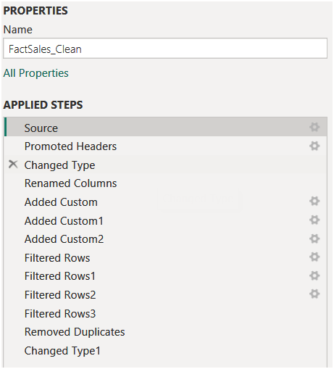

The cleaning was done on fully sold out transactions. Any row without product description was excluded because it was difficult to interpret the product analysis for such a row. Negative quantities and cancellation records were excluded as dashboard was meant to reflect completed sales. To minimize the potential for totals to be overstated, exact duplicate rows were removed from UnitPrice and, after filtering out values that were less than or equal to zero, the data was aggregated by line item. A SalesAmount field was added which is the sum of the product of Quantity and UnitPrice, and a SalesDate field was added to support time-based reporting from InvoiceDateTime.
Table 4: Main Power Query ETL Steps Applied to the Retail Dataset
Data issue or requirement | Power BI transformation applied | Purpose in the report
Missing product description | Removed null or blank descriptions | Improves product-level analysis
Cancelled or returned sales | Filtered negative quantity and cancellation status | Keeps dashboard focused on completed sales
Invalid price values | Kept UnitPrice greater than zero | Avoids misleading revenue calculations
Duplicate transaction rows | Removed exact duplicate rows | Reduces risk of overstated totals
No revenue field | Created SalesAmount = Quantity × UnitPrice | Enables sales revenue analysis
Date-time field not ideal for trends | Created SalesDate and date attributes | Supports monthly and yearly trend charts
Raw table too detailed for reporting | Created fact and dimension tables | Supports dimensional modelling and dashboard filtering

Once transformed, the data was then loaded into the Power BI model. Separate dimensions were created for product, customer, date and country. This enabled to analyse the same measures from different angles, including sales per month, sales per product and the sales per country.

Data Visualisation and Enhanced Decision-Making
The Power BI dashboard was designed to give SMP Retail a practical overview of sales performance. The first page presented KPI cards for total sales, total invoices, total customers and average basket value.
Figure 6: SMP Retail Sales Performance Dashboard
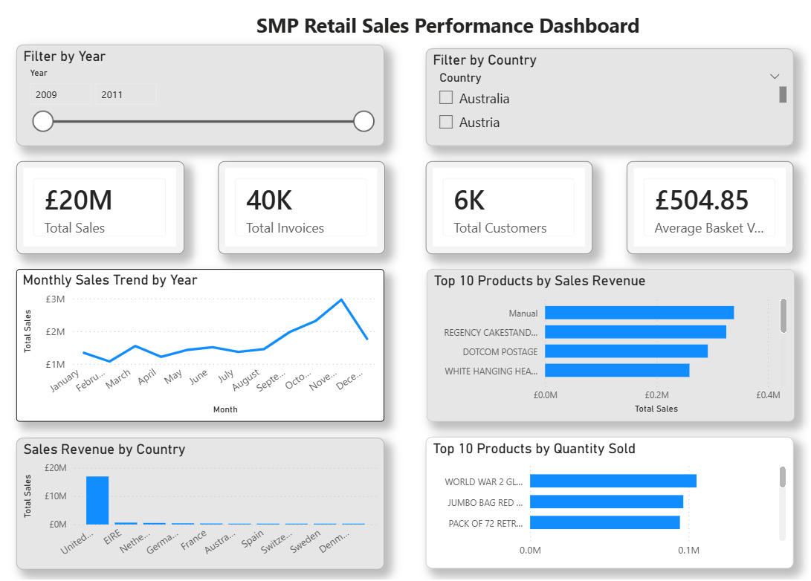

The dashboard total sales were about £20M, there were about 40K invoices, about 6K customers and an average basket value of about £504.85. These are the numbers to give a quick idea of how well the rest of the world is doing. The monthly sales trend chart can be used to show time-based sales movement, which can be used to facilitate stock planning support, promotion timing support and staffing decisions.
The visuals of the product included Top 10 Products by Sales Revenue and Top 10 Products by Quantity Sold. This is helpful as the product with the highest volume isn't always the product that makes the most money. Revenue analysis can help with both pricing and promotions and quantity analysis can help with replenishment and stock control.
Figure 7: Product Sales Detail Analysis Dashboard
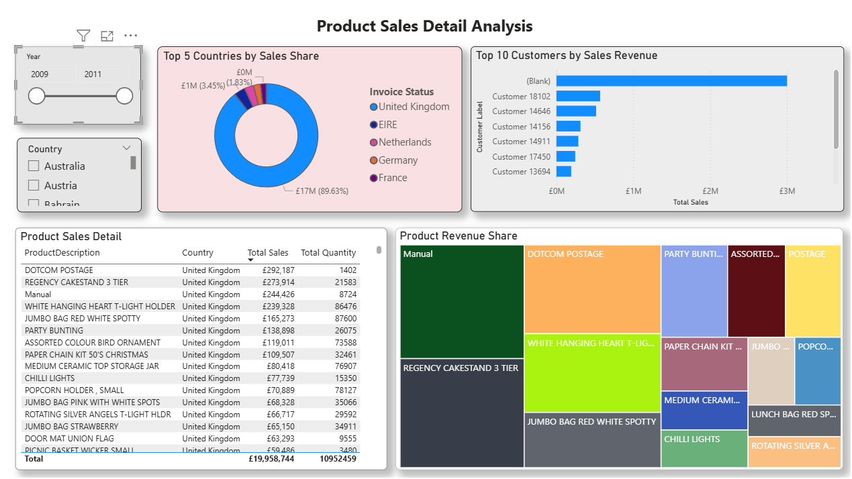
The second dashboard page featured product detail, the top customer analysis, and product revenue share. The slicers, one for year and another for country, made the report interactive, so that users could focus the analysis without having to create a separate report for each. In sum, the dashboard illustrates how a warehouse model and BI tool can help SMP Retail jump from just having data from the point of sale to real-world warehouse performance.

Ethical Concerns: Privacy, Security and Bias
Retail data warehouse poses ethical risks around their integration of customer, product and sales information into a single platform. First issue is the privacy. Purchase history can be used by you to learn your customers' behaviours, their spending, and location data. Suppose customer IDs are substituted for names, this information may turn out to be identifiable if combined with data in loyalty or demographic records. SMP Retail should therefore handle customer's information lawfully, fairly and transparently, with the principles of UK GDPR (ICO, 2023).
Data minimisation also is vital. Only the data to accomplish certain purposes to support SMP Retail's business shall be collected and maintained. ICO (n.d.-a) guidance refers to organisations holding ≤ what is required for the purpose, minimal personal data. In this project, though, CustomerID and Country were sufficient to analyse customers and their geography, a true loyalty system could involve more sensitive personal data. These can only be added in case of need.
Security is a significant other concern. A good way to get things reported is to centralize them in a warehouse, but then again there's the other side of the equation. To ensure that role-based access control, strong authentication, encryption, audit logs and regular access reviews are implemented at SMP Retail. NIST (2025) is also relevant for privacy risk management as a good practice of responsibly handling data.
There's also the risk of bias. There may be a temptation to segment customers solely based on purchase value, which could leave other segments of spending customers unaddressed. Some locations might be inaccurately identified as underperforming if regional and/or store data is lacking. For SMP Retail, an evaluation of segmentation rules, plus observing data quality and preventing the dashboards from taking the place of human judgement is essential.
Table 5: Ethical Risks and Mitigation Strategies for SMP Retail
Ethical risk | Example in SMP Retail | Mitigation strategy
Privacy risk | Customer purchase history may reveal behaviour patterns | Use lawful basis, privacy notices and data minimisation
Security risk | Central warehouse contains valuable sales and customer data | Apply role-based access, encryption, authentication and audit logs
Bias risk | Segmentation may favour only high-spending customers | Review targeting rules and monitor unfair exclusion
Data quality risk | Missing or duplicate records may distort dashboards | Use profiling, validation rules and regular cleansing
Retention risk | Old customer records may be kept longer than needed | Apply retention schedules and anonymise historical data where possible

Conclusion
For SMP Retail, the problem isn't the data that's missing, it's the fact that there is no single analytical structure. While store-level POS records are helpful for the day-to-day store, they lack the broader perspective that is needed to assist in product planning, customer analysis, inventory control and performance comparison. A data warehouse is a solution to this issue by centralising and organising these transactional data to be analysed.
The proposed design used ERD and snowflake schema to demonstrate how sales information can relate to customer, product, invoice, date, time and geographic dimensions. The retail data was cleaned using Power Query, modelled using fact and dimension tables and visualised using dashboards, demonstrated in the Power BI prototype. The dashboard made it possible to analyze the totals of sales, monthly trends, performance of products, customer value and country-level revenue.
But the warehouse should be in use responsibly. Governance controls are required to address the following risks: Privacy, security, data minimisation, retention and bias. With these controls in place, the proposed warehouse can serve as a solid foundation for data-driven decision making when used by SMP Retail

References
ICO (2023) A guide to the data protection principles. Available at: https://ico.org.uk/for-organisations/uk-gdpr-guidance-and-resources/data-protection-principles/a-guide-to-the-data-protection-principles/ (Accessed: 12 May 2026).
ICO (n.d.-a) Principle (c): Data minimisation. Available at: https://ico.org.uk/for-organisations/uk-gdpr-guidance-and-resources/data-protection-principles/a-guide-to-the-data-protection-principles/data-minimisation/ (Accessed: 13 May 2026).
Inmon, W.H. (2005) Building the data warehouse. 4th edn. Hoboken, NJ: John Wiley & Sons.
Kimball, R. and Ross, M. (2013) The Data Warehouse Toolkit: The Definitive Guide to Dimensional Modeling. 3rd edn. Indianapolis: Wiley.
Microsoft (2024) Understand star schema and the importance for Power BI. Available at: https://learn.microsoft.com/en-us/power-bi/guidance/star-schema (Accessed: 8 May 2026).
Microsoft (2025) Model relationships in Power BI Desktop. Available at: https://learn.microsoft.com/en-us/power-bi/transform-model/desktop-relationships-understand (Accessed: 12 May 2026).
Microsoft (2026) What is Power Query? Available at: https://learn.microsoft.com/en-us/power-query/power-query-what-is-power-query (Accessed: 13 May 2026).
Nabil, D.H., Rahman, M.H., Chowdhury, A.H. and Menezes, B.C., 2023. Managing supply chain performance using a real time Microsoft Power BI dashboard by action design research (ADR) method. Cogent Engineering, 10(2), p.2257924.
NIST (2025) Privacy Framework. Available at: https://www.nist.gov/privacy-framework (Accessed: 13 May 2026).
Dang Quoc, H. (2025) ‘Appling Power BI for improved retail business analytics and decision-making’, Applied Computer Science, 21(2), pp. 154–163. doi: 10.35784/acs_7130.
UCI Machine Learning Repository (2019) Online Retail II [Dataset]. Available at: https://archive.ics.uci.edu/dataset/502/online%2Bretail%2Bii (Accessed: 18 May 2026).

Appendices

Appendix A: Power Query Cleaning and Transformation Evidence
Figure: Appendix A1 Power Query Applied Steps for Cleaning and Transforming the Fact Sales Table
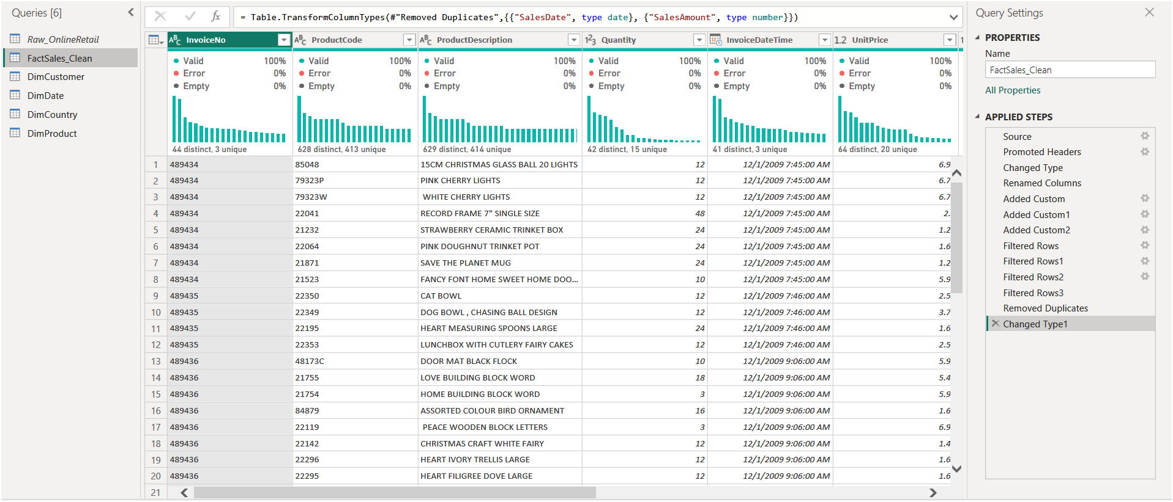
Figure: Appendix A2 Data Type Changes Applied in Power Query
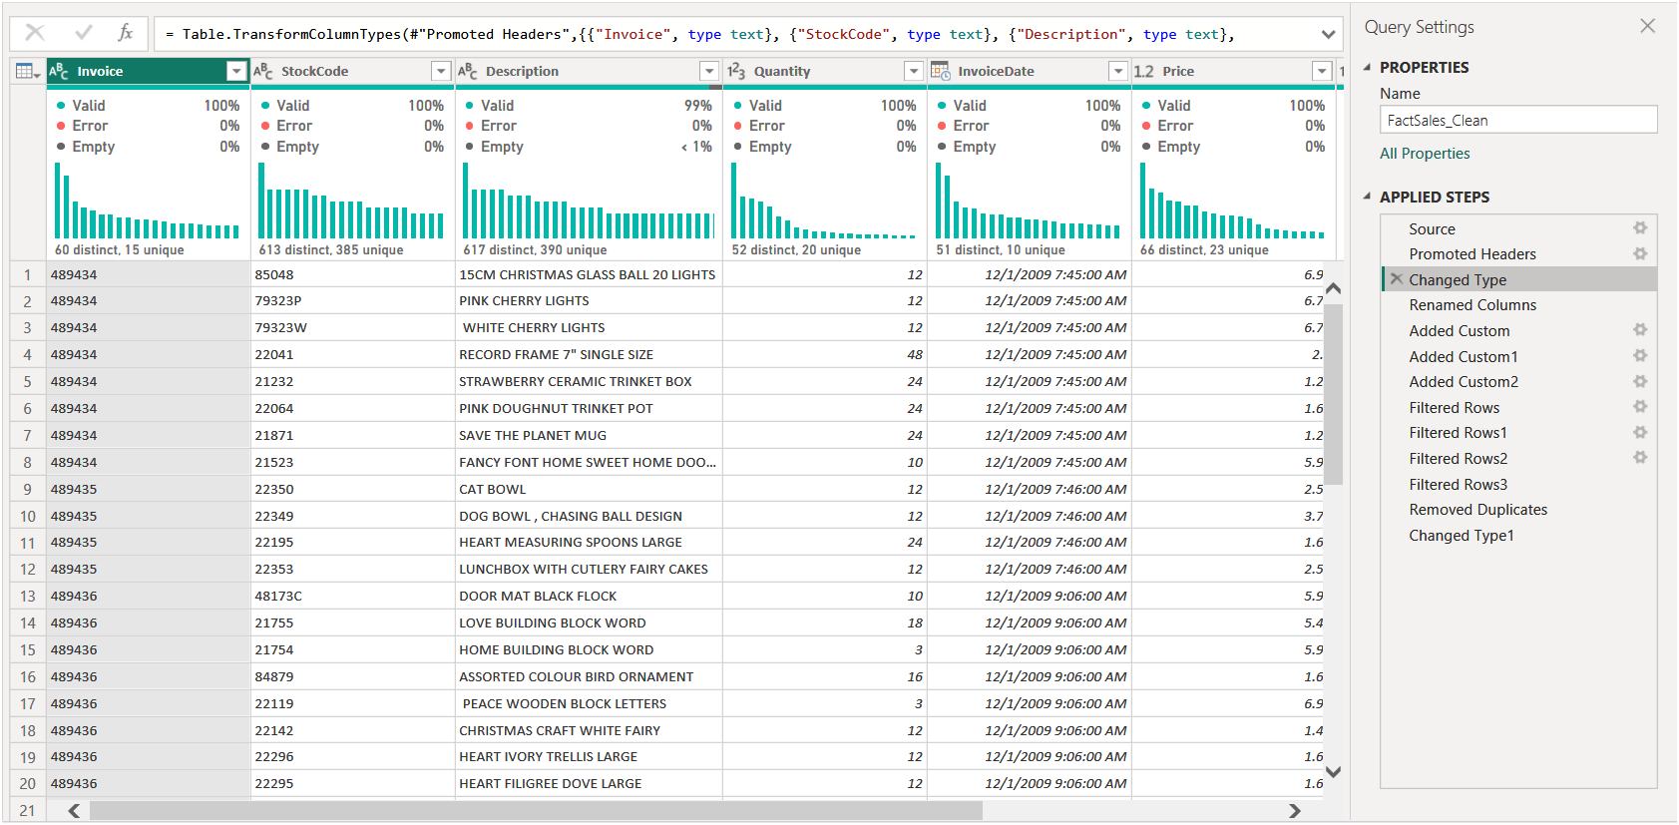

Figure: Appendix A3 Calculated Columns Created for Sales Analysis
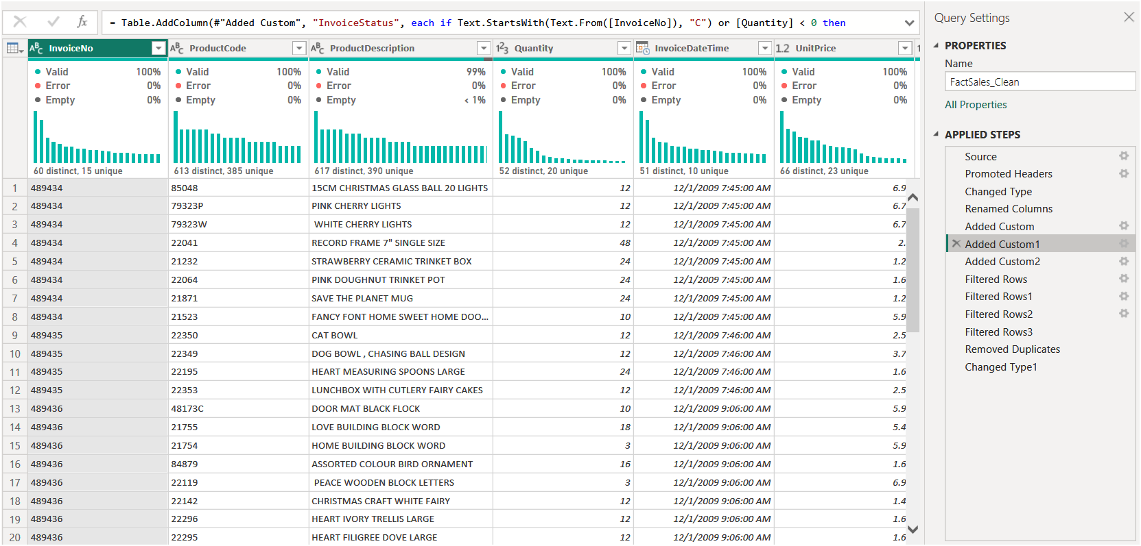
Figure: Appendix A4 Filtered Rows Applied During Data Cleaning


Figure: Appendix A5 Duplicate Removal Step Applied to Transaction Records
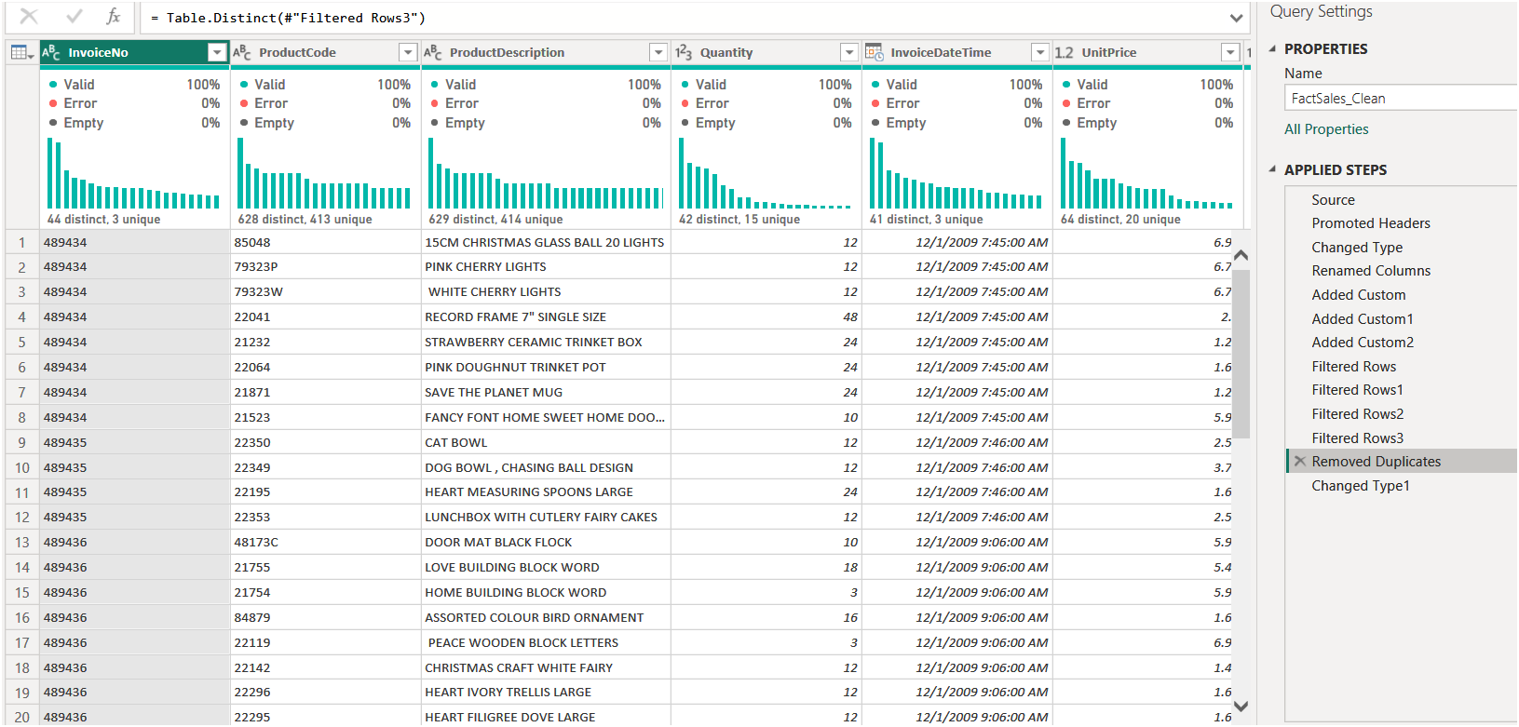

Appendix B: Power BI Data Model
Figure: Appendix B Power BI Data Model Showing FactSales_Clean Connected to Dimension Tables
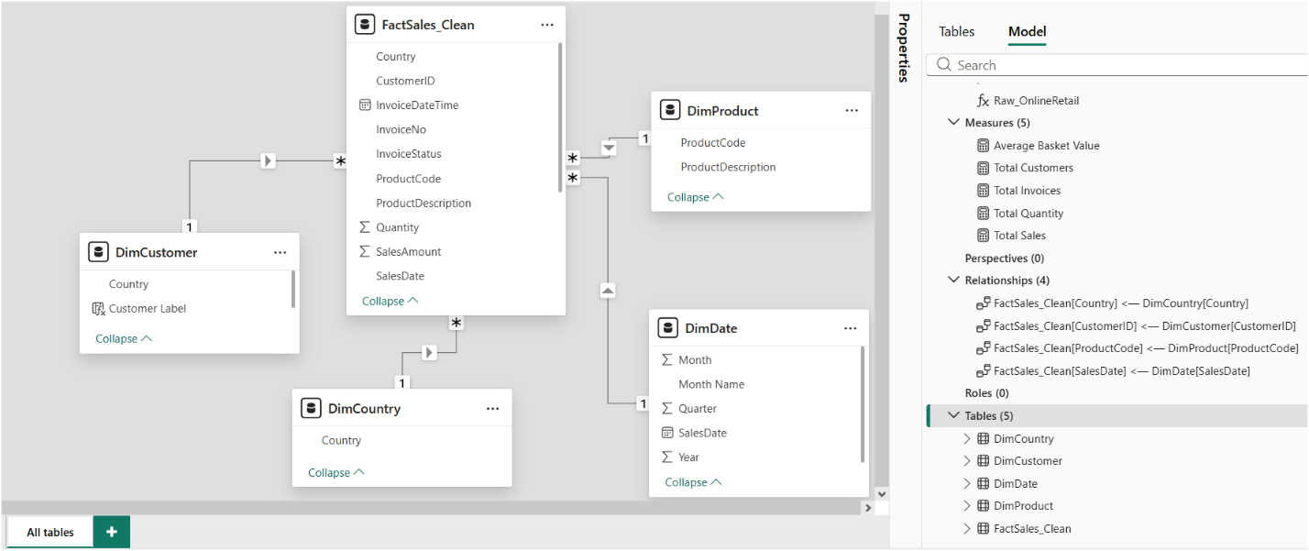

Appendix C: DAX Measures Used
Total Sales = SUM(FactSales_Clean[SalesAmount])
Total Quantity = SUM(FactSales_Clean[Quantity])
Total Invoices = DISTINCTCOUNT(FactSales_Clean[InvoiceNo])
Total Customers = DISTINCTCOUNT(FactSales_Clean[CustomerID])
Average Basket Value = DIVIDE([Total Sales], [Total Invoices])

